**A Beginner’s Guide to Power BI: Exploring Data View, Model View, and Report View**

[Power BI](https://learn.microsoft.com/en-us/power-bi/fundamentals/power-bi-overview) is a widely used business tool which is utilized for business intelligence and which gives us the right business insights. You are looking for the power BI course or you already know the basics and want to get deeper knowledge of the tool besides learning the critical methods of Data View, Model View, and Report View since it is a must-have skill to acquire and without it, you will not be able to get the knowledge of power bi. Utilizing Human Brain Mechanism Power BI is a personal interface that allows the user to run Power BI software through the use of artificial intelligence and machine learning based algorithms, along with different data sources and databases. These options represent an illustration of how Power BI uses things and correct interpretation of them will largely develop your analytical abilities. Let's uncover these views in more detail.

**1. Data View: The Foundation of Your Analysis**

The [Data View](https://learn.microsoft.com/uk-ua/power-bi/connect-data/desktop-data-view) in Power BI is your starting point. It’s in which you get a close look at the uncooked facts you’ve imported, similar to how you will view a desk in Excel. Think of this as the muse of your complete evaluation technique. Before you begin reading or visualizing, it’s critical to understand the data you’re operating with, and that’s precisely what the Data View helps you do.

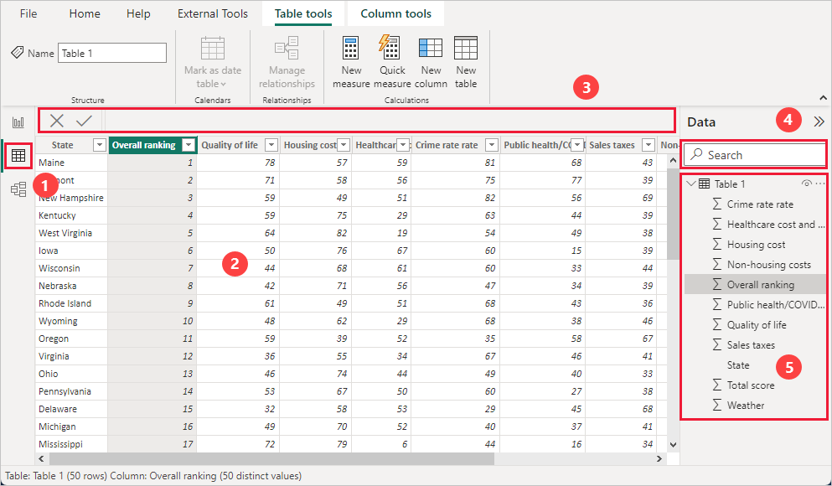

*(Source:Microsoft)*

***What Does the Data View Offer?***

*Data Exploration:-* In this view, you can get the raw statistics in a trustworthy table layout. Here it is possible to be familiar with rows and columns, and understand the sorting, and ensure the whole lot is as expected.

*Data cleaning:-* Sometimes, in your statistics there would be some errors, missing values, duplicates, or inconsistent entries. The data View lets you know these problems early on, so that you can ease your fact before going forward.

.

*Column Adjustments:-* You can create calculated columns, adjust existing records, and upload custom columns to better fit your evaluation desires. This ensures that your statistics are in excellent shape before diving into deeper evaluation.

In short, the Data View is like your data’s home base. It’s where you ensure everything is in order, placing the level for the evaluation to return.

**2. Model View: Connecting the Dots**

After familiarizing yourself together with your information, the next step is to arrange it in a manner that makes sense for evaluation. This is in which the [Model View](https://learn.microsoft.com/en-us/power-bi/transform-model/desktop-relationship-view) comes into play. The Model View lets you define relationships among distinctive tables, create hierarchies, and make certain that your statistics version is nicely-established for analysis.It is also called Relationship view.

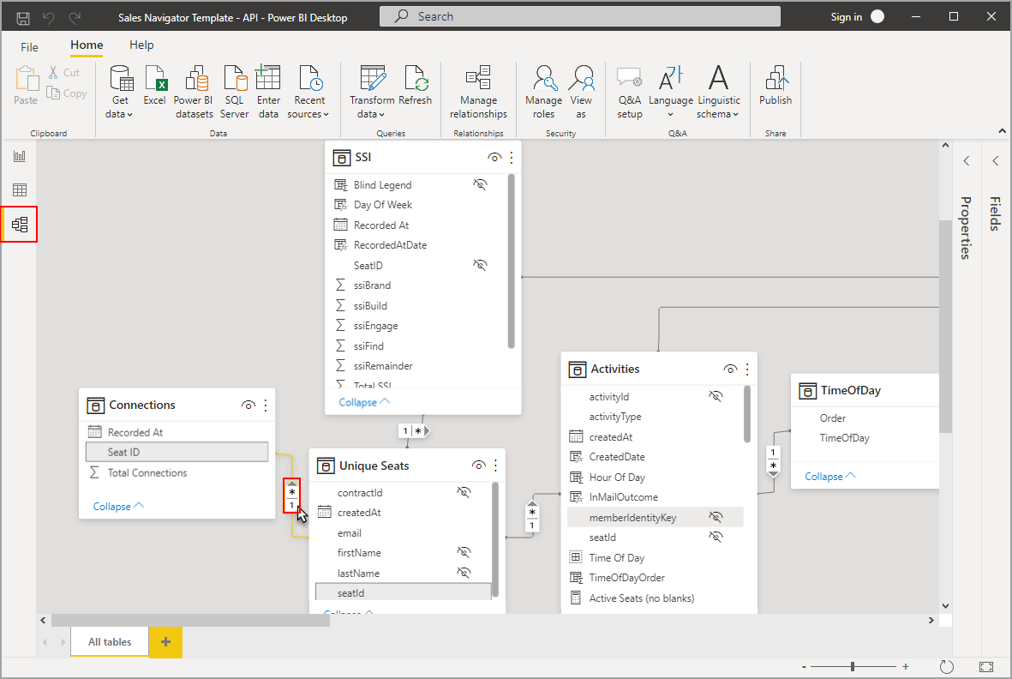

*(Source:Microsoft)*

***Key Features of the Model View:***

*Establishing Relationships:-* If you’re working with multiple tables, the Model View lets you create relationships between them. For instance, if you have a sales table and a clients table, you could link those tables primarily based on a common field like customer ID. This guarantees that Power BI knows how the data is hooked up, permitting extra accurate evaluation.

*Designing the Data Model:-* The Model View is like a blueprint on your records. Here, you’re no longer simply looking at the facts however additionally defining how distinct pieces of statistics relate to every different. This enables Power BI pull together the proper records while you start creating visualizations.

*Creating Measures and Calculated Fields:*- In this view, you could also define measures (aggregated calculations) that may be used across your reviews. This enables summarizing your statistics in significant methods.

In essence, the Model View is about structuring your records in a manner that maximizes the price you can extract from it. It’s where you set up the rules that govern how distinctive statistics factors have interaction.

**3. Report View: Where Insights Come to Life**

The final and most dynamic part of Power BI is the [Report View](https://learn.microsoft.com/en-us/power-bi/create-reports/desktop-report-view). This is in which you take the whole thing you’ve prepared within the Data and Model Views and begin growing visualizations that inform a tale. The Report View is what most humans think about when they think of Power BI—it’s wherein the magic takes place.



***What Can You Do within the Report View?***

*Build Visuals:-* This view permits you to create numerous styles of visualizations, which include charts, graphs, maps, and more. You absolutely drag and drop fields to construct visuals that constitute your statistics in the most insightful way.

*Design Dashboards:-* You can arrange multiple visuals on a single page to create a dashboard. This is notably useful for giving a complete evaluation of your records at a glance.

*Interactive Reports:-* One of the effective features of Power BI is interactivity. In the Report View, you may make your visuals interactive, permitting customers to click on distinctive [factors to filte](https://docs.google.com/document/d/1KnetsvKdb8wu83Exz6Jwzlo3rgG1F2GsYhXpcZyHIkM/edit)r and explore information in real-time.

The Report View is where the entirety comes together. It’s wherein you remodel your established data into insights which could force enterprise choices. The visuals and dashboards you create right here are what quit customers will interact with, making it the maximum outward-dealing with a part of Power BI.

**Conclusion**

Power BI is a versatile tool that allows you to turn raw data into precious insights, and understanding its middle additives—Data View, Model View, and Report View—is prime to harnessing its complete capacity. The Data View facilitates you getting familiar with your data, the Model View structures it for analysis, and the Report View is wherein you carry your insights to existence through visualizations. By learning these perspectives, you could efficiently use Power BI to make data-driven decisions which could propel your business ahead.